For Immediate Release
Back Pack Free Friday May 4th, 2012
Lifting the Burden off Children and Schools

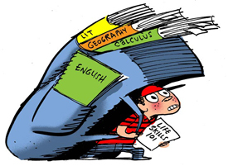
Every day millions of children go to school tired, dehydrated, and many times also hungry. Back Pack Free Friday focuses public awareness on the very real burdens lack of appreciation for children’s foundational health places on children and schools. Back Pack Free Friday is sponsored by an international consciousness movement called Parenting 2.0 (P20), the top ranked parenting group on LinkedIn with nearly 1700 members in more than 40 countries, P20 advocates a more proactive educational process for non-academic Life Skills.
P20 defines Life Skills as all the non-academic, foundational skills children learn to thrive and commune optimally with others. Life Skills include but are not limited to: personal care, safety, finance, organizational, interpersonal communication and social skills.
As stated in their group description on LinkedIn, “Parenting 2.0 supports parents, professionals, and other primary caregivers in their role as Life Skills Educators. Our goal is that, one day, children's LSA (Life Skills Average) will receive the same appreciation as children's GPA (Grade Point Average.)
P20 invites everyone to support Back Pack Free Friday and Stand Up for the welfare of children everywhere by doing the following on Friday May 4th, 2012.
- Leave back packs at home this day.
- Prioritize sleep, hydration, nutrition, and exercise.
- Find creative ways to underscore the importance of water, sleep, nutrition and exercise, for all aspects of children’s performance.
- Shine light upon professionals who can speak to the importance of prioritizing personal care.
- Share the concept of the Life Skills Report Card.
Contact: (add your name, title and contact info here)
ATTACH REAL PHOTO OF CHILD AND BACK PACK, along with Back Pack Cartoon.
Additional info available at http://parenting2pt0.org/

